Test Cases & Tables
atos
holiday chat agent – synoptic project
Jamie Butler
2021

Contents
Automated Testing 0
Manual Testing 0

Automated Testing
The program utilises the built-in React testing library as well as the Jest testing library. These two libraries assist in unit and integration testing in JavaScript programs, offering a clear depiction of test code coverage. Below are the screen shots of the component unit tests and them passing.

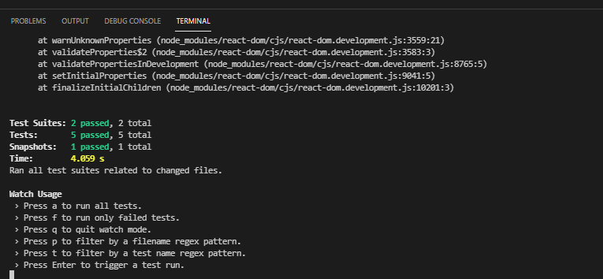

As most of this program is web-based and reliant on a user interface, manual testing of the programs UI was a suitable way to ensure usability, quality and the program renders correctly. The test plan is shown below.

Manual Testing
Test | Expected Result | Actual Result | Pass
Renders NavBar | Pass | Pass | Yes
Renders all links | Pass | Pass | Yes
Matches snapshot | Match snapshot | Pass | Yes
Renders Chat Agent | Pass | Pass | Yes
Render toggle buttons | Pass | Pass | Yes
As most of this program is web-based and reliant on a user interface, manual testing of the programs UI was a suitable way to ensure usability, quality and the program renders correctly. The test plan is shown below.

Test | Expected Result | Actual Result | Pass
Open Application, NavBar renders with header, route buttons and appropriate titles | NavBar renders with Header, two page-route buttons and a Chatbot title. | As expected. | Yes
Chatbot does not render after initial page render, as well as further renders. | Chatbot does not render when Home page is initially routed to and re-routed to. | As expected. | Yes
Chatbot toggle buttons and Title only render on Home page. | Chatbot toggle buttons/title do not render on About page. | As expected. | Yes
Chatbot renders on correct page-route. | Chatbot, and toggle buttons, only appear on the Home page, not the About Page. | As expected. | Yes
Chatbot toggle buttons toggle the visibility of the Chatbot. | Chat Icon toggles Chatbot on, and Close Icon toggles Chatbot off. | Partially, both buttons can technically toggle the Chatbot.  See known bugs for details. | Partial
Chatbot toggle buttons conditionally render based upon chatbot visibility 1.0 | When the Home page is rendered, the close button should not be visible | As expected. | Yes
Chatbot toggle buttons conditionally render based upon chatbot visibility 2.0 | When the Chatbot is rendered, the close button should be rendered next to the Chatbot toggle button. | As expected. | Yes
Chatbot close button renders the feedback modal after the first Chat Agent session. | Feedback modal appears after the Chat Agent is closed for the first time. | As expected. | Yes
Chatbot renders with the correct initial messages. | “Hey there, I’m Holiday Bot”  “How can I help?”  Both messages render after Chatbot initial render. | As expected. | Yes
Chatbot responds to key word user input e.g., “Book”, “Holiday”, displayed correct response. | Chatbot renders “Great, let’s get you started.” | As expected. | Yes
Chatbot case-options triggers correct Chatbot response. |  | As expected. | Yes
Chatbot input box renders correctly. | “Write your message here” renders. | As expected. | Yes
Chatbot renders user-input messages correctly. | Chatbot renders user-input message after the send button is pressed. | As expected. | Yes.
Feedback close button closes the Feedback modal. | Feedback modal closes. | As expected. | Yes.
The Feedback submit button changes the message to the thank you message. | The text area’s value changes to “Thanks for the feedback!” | As expected. | Yes.

